|  |  |  |  |  |  |
| --- | --- | --- | --- | --- | --- |
| MEMO | | | | |  |
| To: | Hunter and Central Coast Regional Planning Panel | | | | |
| From: | Nicole Sellen, Senior Development Planner | | | | |
| File: | DA/226/2022 | **Reference:** | PPSHCC-120 | Date: | 12 September 2022 |
| Subject: | Supplementary information for Stage 2 Marina at Trinity Point | | | | |

At the determination briefing held on Thursday 8 September 2022, the Hunter and Central Coast Regional Planning Panel (Panel) requested Council staff provide a memo to the Panel addressing the following:

* Concept approved plan comparison
* Car parking
* Pubic use and access of foreshore area
* Ongoing monitoring and compliance reporting
* SEPP (Hazardous and Offensive) Development
* Revised conditions of consent

This memo responds to this request.

**Approved Concept Plan**

The most recent concept plan approval under MOD 2 to MP 06_0309 is presented in Figure 1.

The proposed stage 2 of the marina differs slightly from the approved MOD 2 concept plan as presented in Figure 2. An overlay of the approved concept plan (grey outline) and the proposed stage 2 marina is presented in Figure 3.

The slight difference to the layout has taken into consideration the Concept Approval Condition B1 which requires the following:

***Consent Condition - B1 Construction of Marina***

*Prior to lodgement of a future project application for the marina the design is to be reviewed to ensure the following performance criteria are met:*

• *Minimise change to water flow in and around the marina;*

• *Minimise change to the flushing characteristics and the water quality of Bardens Bay;*

• *Minimise wave bounce to ensure negligible impact on the seagrass wrack;*

• *Ensure appropriate movement of seagrass wrack into Bardens Bay;*

• *Minimise visual impact; and*

• *Ensure adequate protection from southerly weather patterns.*

*The review and any subsequent modifications to the layout must be submitted to the satisfaction of the Director-General prior to the lodgement of a project application.*

In response to Condition B1 the applicant submitted a response to condition B1 (prepared by Royal HaskoningDHV) which addressed the performance criteria and layout changes to improve the design and continued compliance with the performance criteria. This response was submitted to the Department of Planning and Environment (DPE) prior to lodgement of the Development Application (DA). The response accompanied with a letter from the DPE confirming their support of the layout change and compliance with condition B1 was supplied to Council under Appendix D of the Environmental Impact Statement (EIS). The response to Condition B1 alongside the DPE’s letter of support has been reviewed by Council and considered satisfactory for the following reasons:

* The amended layout remains within the bounds of the marina lease area
* The amended layout is considered substantially the same as the approved concept, with only slight shifts made to Arm B, C and D
* The amended layout does not change existing land/shore based works
* The amended layout does not change the approved number of berths, being 188
* The amended layout does not impact the movement of water, flushing and seagrass wrack around and under the marina.

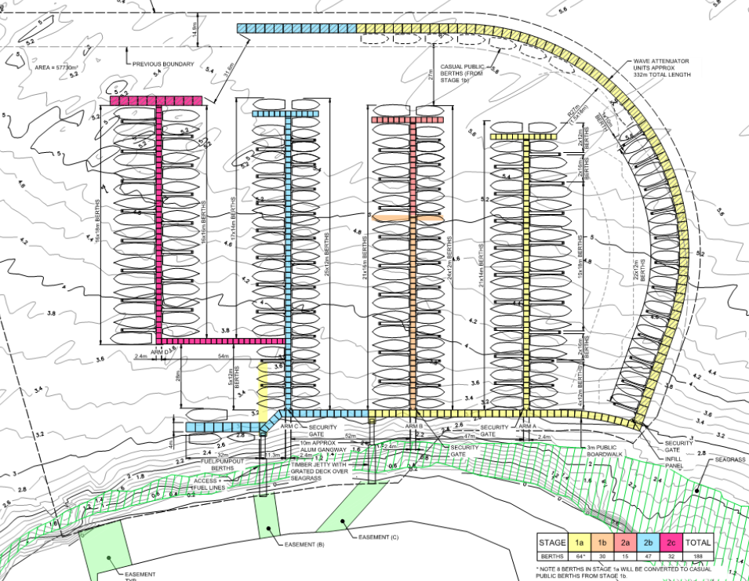

**Figure 1 - Approved Concept Plan**

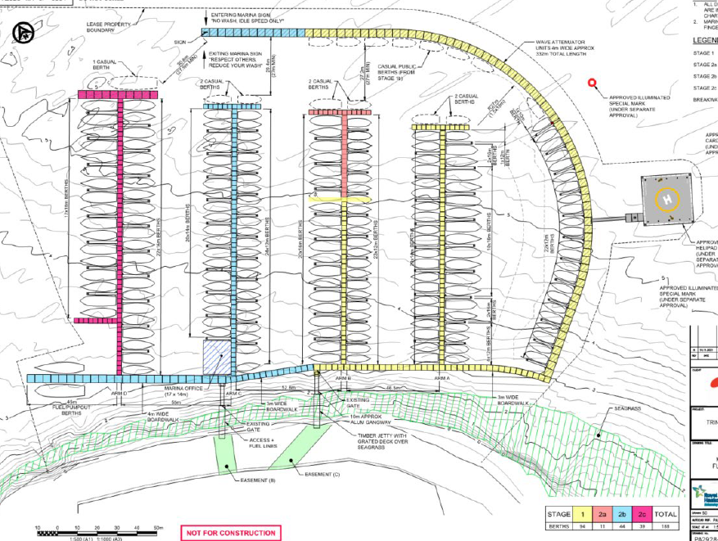

**Figure 2 - Proposed Stage 2 marina**

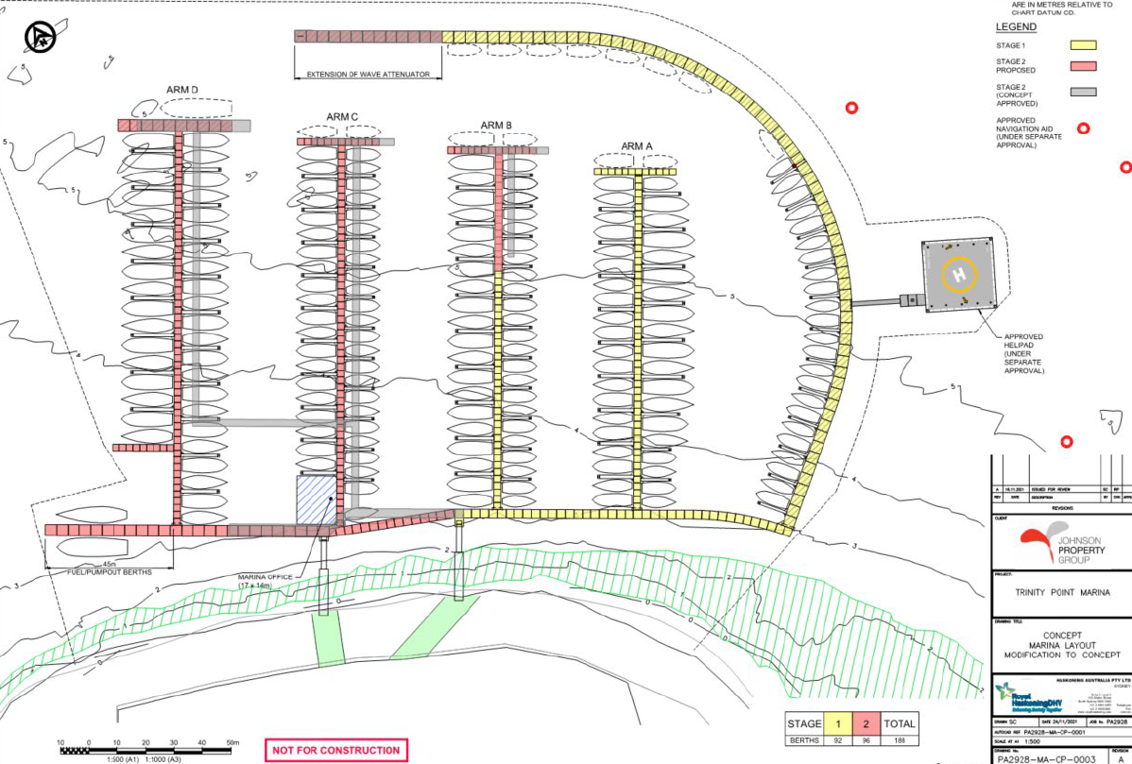

**Figure 3 - Concept Approved Plan and Stage 2 marina overlay**

**Car parking**

As assessed within the Council assessment report, the proposed marina (both stage 1 and stage 2) requires an overall 60 car parking spaces. Draft condition 31 was recommended for the marina car park area to make available 53 car parking spaces for marina uses. This is supplemented by draft condition 29 for signage within the subject car park to be used for marina users only. The reasoning for the draft condition requiring 53 spaces was due to this area only containing 53 spaces.

Based upon the Panel’s comments it is recognised and agreed this is the final application for the marina, and as such consideration should be made for the long term operation of the marina and include assurances the required number of car parking spaces will continue to be provided for.

In light of this, it is proposed to amend the car parking condition (condition 31) to provide a total of 60 car parking spaces for the marina use. The wording of the condition shall be revised to enable the car parking to be provided within the site, not specifically all within car parking area west of the temporary restaurant. The supplementary signage condition (condition 29) shall also be updated to include signage within the car parking area east of the temporary restaurant to ensure a further 7 spaces are made available for marina users.

Details of proposed revised conditions of consent are provided within Appendix A to this memo.

**Public use and Access of foreshore area**

At the public briefing held on 4 August 2022, a submitter raised concerns in relation to public use of the foreshore area. The applicant supplied a response to the concerns raised at the public briefing which has now been made available on the portal. Included within this response was a picture of kayakers and stand up paddle boarders utilising the foreshore area. An image extract is provided below in Figure 4. Stage 2 Marina will not alter the existing gangway access points and as such the development will ensure the foreshore continues to be accessible to the public.

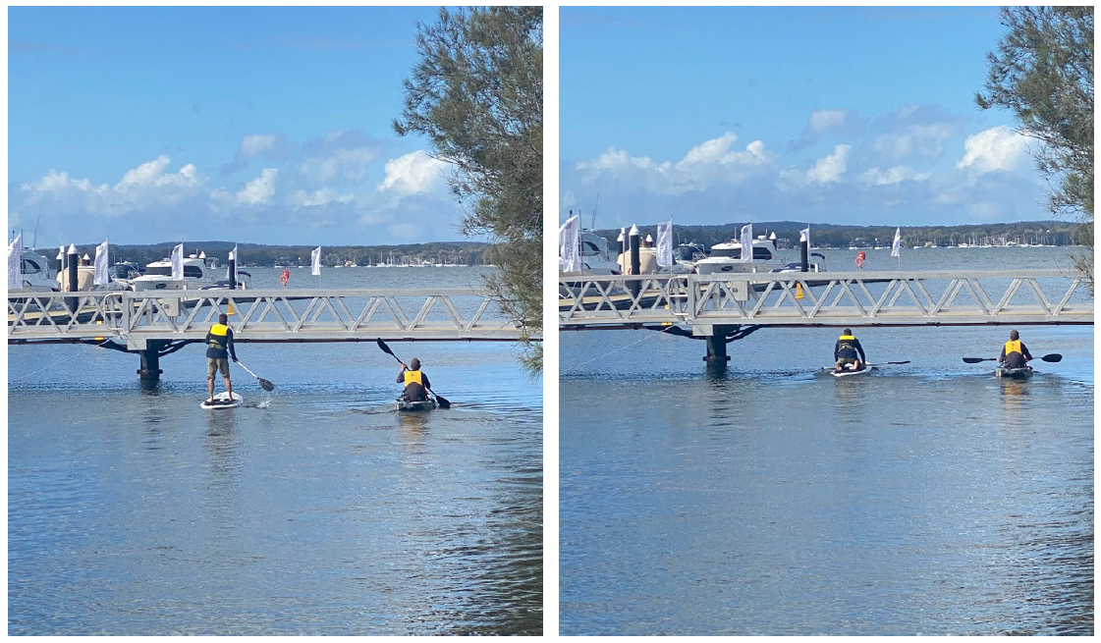

**Figure 4 - Foreshore accessibility**

**Ongoing monitoring and compliance reporting**

The panel raised several questions in relation to the requirements for ongoing monitoring (operationally).

The current draft conditions of consent include environmental performance monitoring and reporting for pre-construction works and post construction works.

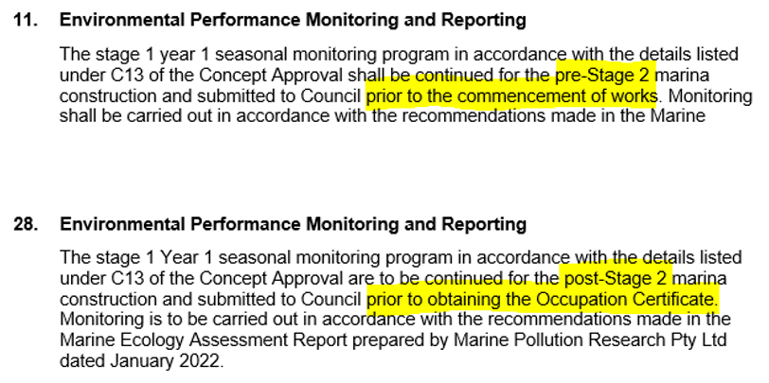

**Figure 5 – extracts of draft conditions for monitoring and compliance**

Beyond the construction period the ongoing monitoring is regulated by the Environmental Protection Licence (EPL). The existing marina operates under an existing EPL (Licence – 20631). The requirements for ongoing monitoring are set out under Part 5 of the licence. Extracts of Part 5 are provided below. Draft condition 26 requires the EPL to be revised to include Stage 2 of the marina.

A link to the existing monthly reporting is can be found on the Trinity Point website -

[Trinity Point Marina… | Trinity Point Marina - Lake Macquarie, NSW](https://trinitypointmarina.com.au/about/trinity-point-marina-monitoring)

Evidence of existing signage directing the public to the marina office manager or EPA for purposes of complaints/notice of spills is provided in the Figure 9. These are expected to be retained with a conditional requirement for further signage provided at the site.

From the determination briefing, the following actions have been taken in response to ongoing monitoring:

* New condition 41 (operational) – for development to comply with the EPL for the marina, including any ongoing water quality testing and monitoring
* New condition 42 (operational) – signage to be provided in publicly visible areas by the marina amenities building, marina office and near marina gangway access for public to report any issues to EPA
* New condition 43 (operational) - monitoring of foreshore erosion and sediment every 12 months from completion of construction for a period of 3-years. At the end of this time period a revised monitoring period may be considered.

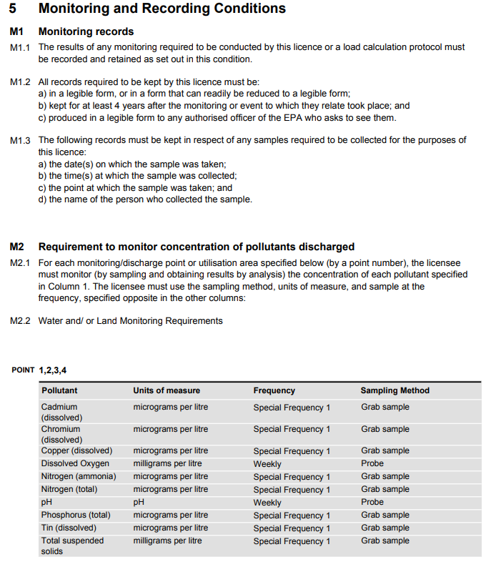

**Figure 6: Extracts of EPL**

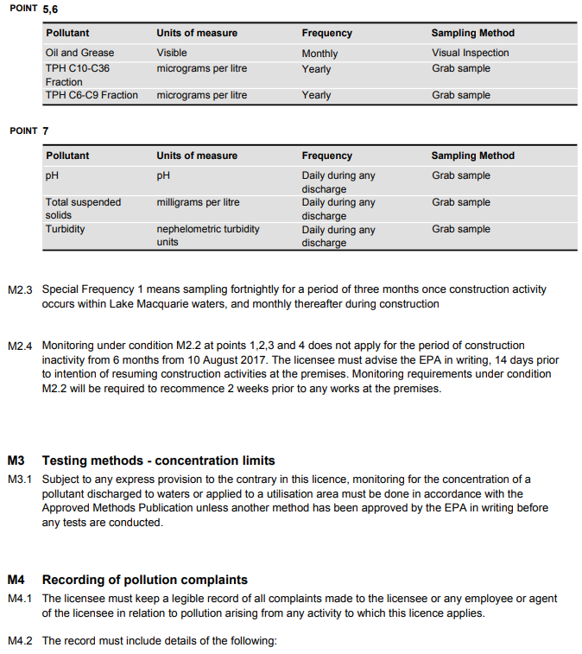

**Figure 7: Extracts of EPL**

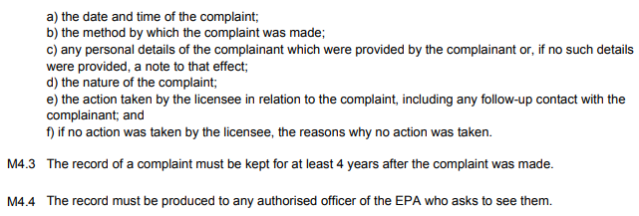

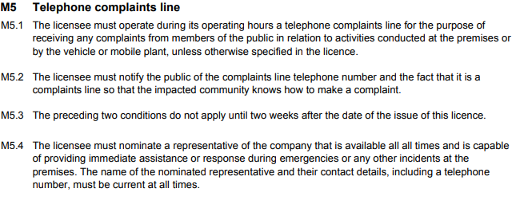

**Figure 8: Extracts of EPL**

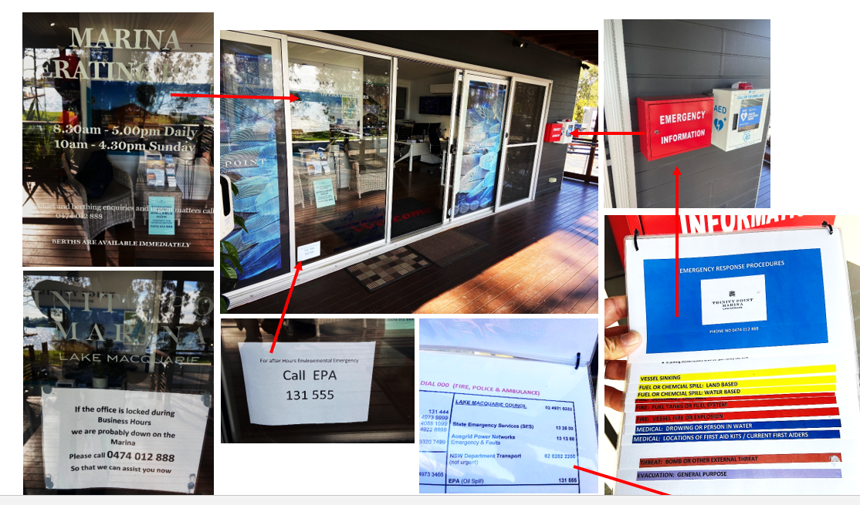

**Figure 9 – Existing on-site signage**

**State Environmental Planning Policy (Resilience and Hazards) 2021**

During the briefing further information was requested in relation to the proposed reorientation of the fuel wharf and measures in place to ensure to hazardous development was occurring.

Stage 1 of the marina included an underground split fuel tank with 15,000L compartment for diesel and a 10,000L compartment for premium unleaded petrol. The existing tank is double walled fibreglass. Pipework to supply the fuel facility from the underground tank to the wharf is double walled High-Density Polyethylene.

As part of the Stage 2 marina works there are no changes to the existing location of the underground tank. Notwithstanding, it is recognised there is a hazardous element to the construction works with the reorientation of the fuel wharf which includes the pipework supply.

The applicant has provided information demonstrating prior to construction activity to reorient the fuel wharf, a work method statement will be prepared. This will include procedures to drain and cap fuel lines prior to disconnecting and re-orientation of the fuel pontoon.

Proposed management measures include:

* Operation of the fuel wharf to be undertaken by marina staff only in accordance with a work method statement to avoid spillage
* Provision of spill kits and containment materials at various strategic points around the site with the marina office and spill shed containing appropriate emergency response materials and booms in reasonable proximity to the marina for deployment as required
* Provision of firefighting equipment at strategic points
* Professionally managed marina with spill control forming part of a day-to-day management practice as part of daily dock walk procedures, general security and maintenance of the facilities to ensure working order and appropriately trained staff in emergency response procedures, including for spills on land or water, and fire incidents
* No major maintenance of fuel pump equipment to be undertaken on-site
* Sleeves to be fitted over hydraulic hoses on equipment operating on or near the waterway to capture any hydraulic fluid that may be spilt from a ruptured hose or an alternative mitigation measure in lieu of sleeving that achieves the same water quality management intent such as use of biodegradable hydraulic oil, regular pre-start hose/pump inspections, floating boom or other suitable measures
* Any worn or damaged hoses, joints or connections identified during inspections to be replaced prior to their use.

Proposed draft condition 8 requires the abovementioned information to be included in a revised Construction Environmental Management Plan (CEMP).

Pursuant to Chapter 3 – Hazardous and offensive development of this SEPP the proposed re-orientation is not considered to fall under hazardous industry or offensive industry. Council are satisfied the proposed re-orientation of the fuel wharf will include suitable measures in place to ensure the works are no hazardous or offensive. Operation of the fuel service will be haltered during the stage at which the re-orientation of the fuel wharf is undertaken and suitable measures shall be placed to ensure no leakage impacts occur.

**Conditions of consent**

The following table outlines the conditions proposed to be modified, the condition description, and changes made.

A copy of the draft conditions with track changes is attached at Appendix A to this memo.

|  |  |  |
| --- | --- | --- |
| **Condition no.** | **Condition description** | **Change** |
| 2 | Approved Documentation | Inclusion of Environmental Impact Statement at the request of the proponent |
| 8 | Construction Environmental Management Plan | Grammatical update |
| 9 | Marina Piles | Grammatical update |
| 10 | Rathmines Park | Grammatical update |
| 11 | Environmental Performance Monitoring and Reporting | Grammatical update |
| 13 | Topsoil and Stockpiles of Materials | Deleted – not relevant |
| 14 | Fix Damage Caused by Construction Works | Deleted – to be done prior to OC (Condition 23) |
| 19 | Noise – Construction Sites | Updated to be consistent with EPL |
| 24 | Geotechnical Report Review Compliance | Grammatical update |
| 25 | Marina Car Park – Boom Gate | Delete – at the request of the proponent |
| 26 | Environmental Protection Licence | Grammatical update |
| 27 | Tethered Bouys | Updated to reflect works within lease area only – requested by proponent |
| 28 | Environmental Performance Monitoring and Reporting | Grammatical update |
| 29 | Signage | Updated to accommodate the Panels request for a further 7 allocated car parking spaces within the site. |
| 30 | Rathmines Park | Updated to accommodate the Panels request for a further 7 allocated car parking spaces within the site. |
| 31 | Use and Allocation of Car Parking | Updated to accommodate the Panel’s recommendation (60 car parking spaces) |
| 34 | Storage of Maritime Vessels | Grammatical update |
| 39 | Emissions | Deleted – covered under EPL |
| 40 | Trinity Point Marina Operations Manual | Grammatical update |
| 41 | Environmental Protection Licence | Added to include operational requirement to comply with EPL |
| 42 | Complaints Signage | Added to make complaints line signage available at marina amenities building, marina office and access points. |
| 43 | Ongoing Foreshore Monitoring | Added per Panel’s request. |

Should you have any further questions, or require further information to assist in the Panel’s determination of the application, please contact me on 0436 939 136 or nsellen@lakemac.nsw.gov.au.

Nicole Sellen

Senior Development Planner

Development Assessment & Certification

*Appendix A – Revised Draft Conditions of Consent*